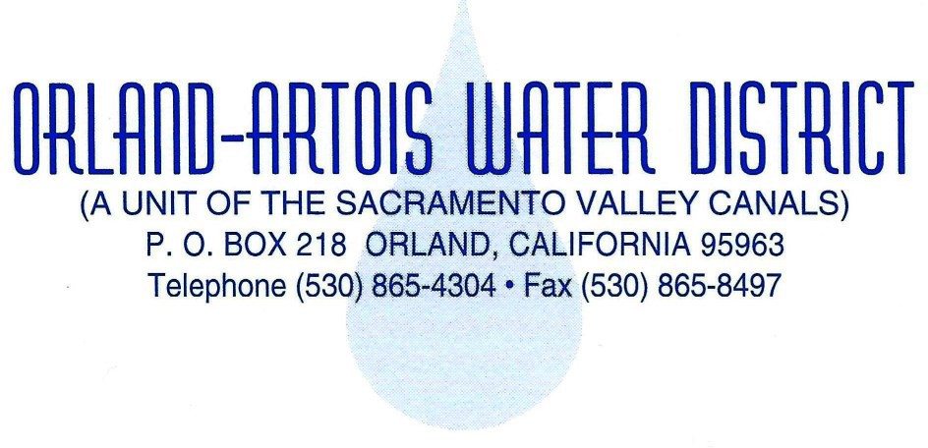 **BOARD OF DIRECTORS**

Mike Vereschagin, President

Charles Schonauer, Vice President James A Jones

Brian Erickson Steve Carlos

**GENERAL MANAGER**

Justin Dahl

SPECIAL MEETING

OF THE

BOARD OF DIRECTORS

OF THE

ORLAND-ARTOIS WATER DISTRICT

Thursday April 17th, 2025

11:30 AM

**Location: Amaris Banquet Hall 709 Fifth St, Orland, Ca 96963**

**AGENDA**

1. Roll Call and Determination of a Quorum.
2. Public Forum.
3. General Business:
   1. Landowner/Water User Luncheon
   2. Guest Speakers:
      1. Glenn Ground Water Authority Update & H20 Tech Update

Presented by: Jeff David’s (David’s Engineering)

* + 1. Orland-Artois Water District Groundwater Mapping Report

Presented by: Nathan Azevedo

(No Action Needed)

1. ADJOURNMENT.